Policing in Chicago Under the Consent Decree: A New Beginning?

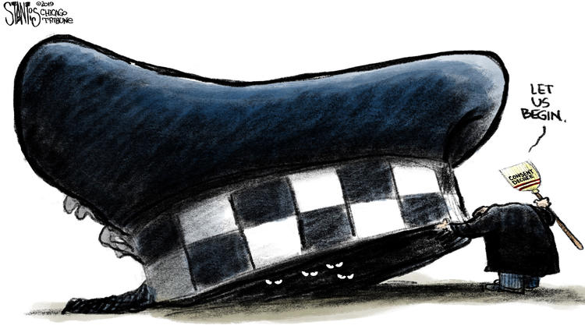

www.chicagotribune.com/stantis

